anjali.sharma200012@gmail.com

**Miss.Anjali sharma**

Mobo. no. .9753812126 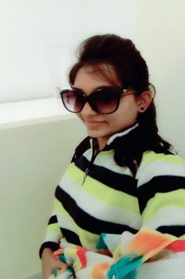

**Qualification:**

**2017-2019 -**

**2012-2016**

**2012**

**2010**

**Objective:**

To Work in competetive envirnoment on challening assingment that shall yield the twin benefit of the job satiesfaction & a steady-paced professional growth & put my abilities & qualification to optimum use.

**Personal Profile**

**___________________________**

Name : Anjali Sharma

Date OF Birth : 12 may1994

Sex : Female

Marital Status: Single

Language Known: Hindi & English

Father’s Name : Mr. Rajendra SharPermanent Address: 1,Piple Gali Near Jain Dharmashala , Barwaha Dist. Khargone(MP)

Mobile No. : 9753812126

Email : anjali.sharma200012@gmail.com

**Present status:-**i am pursuing Degree **Master of Technology(M.Tech)** in **"Computer Science"** Branch from School of Computer Science & IT , DAVV Indor .with **76%** aggregate.

I have been completed my degree of **Bachelor Engineering in Computer Science** from Sardar Patel Institute of Technology & Management , Mandleshwar , in **“Computer Science”** branch with **8.10** CGPA.

Higher Secondary School Certification Exam from Vivekanand Vidhya Vihar Higher Secondry School , Barwaha with **73.6 %**MP Board.

**Technical Activities**

**_________________________**

* WokShop on Algoritham Design & Program Optimization Techniques
* SALESFORCE .
* MSME .
* TECH FOR SEVA ­­
* TECH FISTA- .

High School Certification Exam from Vivekanand Vidhya Vihar Higher Secondry School , Barwaha with **83.16%** MP Board.

**Extra Activity**

**____________________________**

* Volentier, Class Representative(CR).
* President of student council .
* Participant of BHARTIYA SANSKRITI GYAN PARIKSHA.
* Participate in social activities.

**Technical Skills**

**___________________________________________**

* Advance PHP with Codigniter (CI) from VANGARD SOFT TECH , Indore .
* Core PHP with HTML , CSS & MYSQL from Sardar Patel Institute of Technology & Management , Mandleshwar .
* Core C from Sardar Patel Institute of Technology & Management , Mandleshwar.
* introductory knowledge of java, servlet.